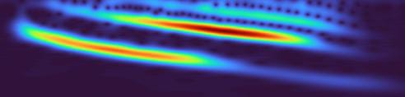

Time–Frequency Analysis of EEG Signals Using Continuous Wavelet Transform (CWT)

Sara Shahama|30-10-2025

# **INTRODUCTION**

Understanding how the human brain organizes movement is a central question in neuroscience. Electrical signals recorded through electroencephalography (EEG) provide a direct and non-invasive way to study these neural processes in real time. My interest in this project arises from a broader curiosity about how different brain regions coordinate their activity during movement and how these dynamics can be quantified through time–frequency analysis.

In this work, I analyzed EEG data from the PhysioNet *EEG Motor Movement/Imagery Dataset* to study activity over the motor cortex during rest and movement conditions. Specifically, I focused on two electrodes—**C3** and **C4**—which correspond to the left and right motor cortices, respectively. These areas are known to play key roles in controlling voluntary hand movements. The main objective of this project was to examine how the spectral content and inter-regional connectivity between these motor areas change when a subject transitions from rest to performing a movement task.

To capture these changes, I used **wavelet transform–based time–frequency analysis**, which provides a way to study how oscillatory activity evolves over time. I quantified the power of canonical EEG frequency bands (delta, theta, alpha, and beta) during baseline and movement periods, with particular attention to the alpha (or mu) rhythm, which is known to desynchronize during motor activation. In addition, I investigated **functional connectivity** between C3 and C4 using two complementary measures: **wavelet coherence**, to assess shared oscillatory patterns across frequencies, and **phase-locking value (PLV)**, to measure consistency of phase synchronization between the two sites.

The broader motivation behind this analysis is to understand how movement-related brain dynamics manifest as changes in oscillatory power and synchrony. Such insights are valuable for developing models of motor control and have practical relevance in areas such as **brain–computer interfaces (BCIs)** and **neurorehabilitation**, where decoding motor-related brain signals plays a key role.

This project allowed me to integrate concepts from signal processing and neuroscience in a concrete way. Through analyzing how brain rhythms reorganize during movement, I gained a deeper appreciation of how quantitative EEG analysis can reveal functional patterns underlying human behavior.

# **METHODOLOGY**

*Data Source*

The data used in this study were obtained from the **EEG Motor Movement/Imagery Dataset** available on *PhysioNet*. This open-access database contains EEG recordings from healthy adult participants who performed various motor tasks, including resting with eyes open and closing or opening their fists. For this project, I selected one subject (S001) and used two recordings:

* **S001R01.edf** – baseline, eyes-open resting condition
* **S001R03.edf** – movement condition (subject performs or imagines hand movement)

Each recording includes 64 EEG channels sampled at 160 Hz. Among these, I focused on **C3** and **C4**, which correspond to the left and right motor cortices. These sites are well-established in motor control research: C3 primarily reflects right-hand movement, and C4 reflects left-hand movement. Focusing on these electrodes allowed me to study neural activity directly related to motor processing.

*Preprocessing*

The EEG data were imported and processed in **R** using the edfReader package. For each recording, I extracted the raw signals from C3 and C4 and removed their mean values to eliminate DC offset. Both signals were trimmed to the same length to ensure proper alignment between baseline and movement conditions. A sampling frequency of **160 Hz** was used throughout all subsequent analyses.

*Time–Frequency Analysis*

To explore how EEG rhythms evolve over time, I used the **Continuous Wavelet Transform (CWT)**, implemented through the WaveletComp package. Wavelet analysis was chosen because it captures transient, non-stationary changes in brain activity — something that traditional Fourier analysis cannot represent effectively. It provides simultaneous resolution in both time and frequency, which is essential when studying motor-related EEG patterns that vary rapidly around movement onset.

For visualization, I generated **scalograms** that show the distribution of signal power across different frequencies and time windows. This helped in identifying distinct rhythmic components and their modulation during rest and movement.

*Band Power Estimation*

To quantify the strength of neural oscillations, I computed the **band power** for four standard EEG frequency bands:

* Delta (1–4 Hz)
* Theta (4–8 Hz)
* Alpha (8–13 Hz)
* Beta (13–30 Hz)

A fourth-order Butterworth band-pass filter was applied to isolate each band. Particular attention was given to the **alpha band**, as decreases in its power during movement reflect *event-related desynchronization (ERD)*.

*Connectivity Analysis*

To assess communication between the two motor areas, I used two complementary connectivity measures:

1. **Wavelet Coherence** — computed using analyze.coherency() from the *WaveletComp* package. This metric captures how strongly two EEG signals co-oscillate across frequencies and over time. High coherence indicates that both regions are oscillating in synchrony, while lower coherence suggests reduced coupling.
2. **Phase Locking Value (PLV)** — derived from the instantaneous phase obtained via the Hilbert transform. PLV quantifies phase synchrony within sliding time windows. It ranges from 0 (no synchronization) to 1 (perfect phase locking). This measure is particularly useful for examining whether two regions maintain stable phase relationships during different behavioral states.

Both analyses were performed separately for baseline and movement conditions, allowing comparison of how inter-hemispheric coordination changes with motor activity.

*Statistical Testing*

To determine whether the observed differences in PLV between baseline and movement were statistically significant, I used a **paired t-test** across corresponding time windows. Since EEG data may not always follow normal distributions, I also implemented a **non-parametric permutation test** to validate the results.

*Rationale for Method Selection*

Wavelet-based analysis was chosen for its ability to handle **non-stationary** EEG signals, where frequency content changes rapidly over time. Combining wavelet coherence and PLV provided complementary perspectives — one frequency-based and one phase-based — on how motor regions interact. This approach aligns well with current practices in time–frequency neuroscience research, where both spectral power and connectivity dynamics are used to interpret brain function during movement.

# **RESULTS AND DISCUSSION**

*1. Time–Frequency Representation*

The continuous wavelet transform (CWT) provided a clear view of how the EEG signal changed between the resting and movement conditions.  
During the baseline period, strong alpha activity was seen over C3— a typical pattern of relaxed wakefulness when the motor system is relatively idle.  
When the participant began moving, there was a noticeable reduction in alpha power.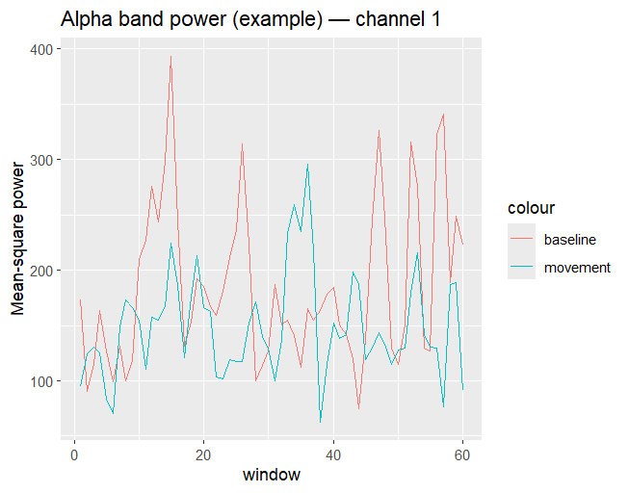

During movement, alpha band power in the brain typically decreases because the brain transitions from a state of rest or inhibition to active processing. Alpha waves, which oscillate between 8–12 Hz, are most prominent when the brain is relaxed and not engaged in demanding tasks. However, initiating movement requires the motor cortex and associated sensory regions to become active, leading to a phenomenon known as event-related desynchronization (ERD), where alpha rhythms are suppressed.

*2.Band Power Changes*

To quantify the observed changes, power within standard EEG frequency bands (delta, theta, alpha, and beta) was computed using a 2-second sliding window with a 1-second overlap.

The alpha band power over C3 was compared between baseline and movement conditions. The resulting plot showed consistently higher alpha power during baseline (red line) and a drop in power during movement (blue-green line).



This confirms that alpha rhythms are suppressed during motor activity, consistent with ERD. The decrease in alpha-band synchronization over C3 indicates that the left motor cortex became functionally engaged during movement, reflecting increased neuronal activation and information processing.

*3. Connectivity Analysis: Wavelet Coherence*

To explore inter-regional connectivity between the two motor areas, **wavelet coherence** between C3 and C4 was computed for both conditions.

* **Baseline:** The coherence map exhibited **strong red and yellow regions** in lower frequency bands (~1–4 Hz), indicating that both hemispheric motor areas oscillated synchronously during rest.

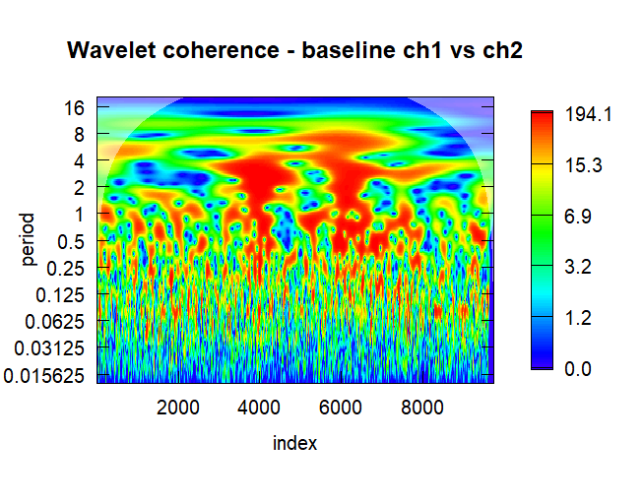

* **Movement:** Coherence became **less intense and more scattered**, suggesting reduced synchronization during active motor engagement.

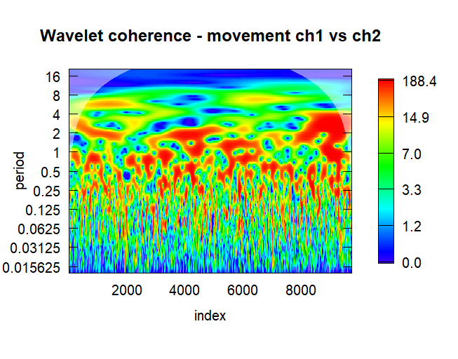

This **reduction in coherence** during movement reflects **functional desynchronization** between the two motor cortices—a common finding in motor-related EEG research. It suggests that, during active movement, the hemispheres operate more independently, allowing for precise, lateralized motor control.

*4. Connectivity Analysis: Phase Locking Value (PLV)*

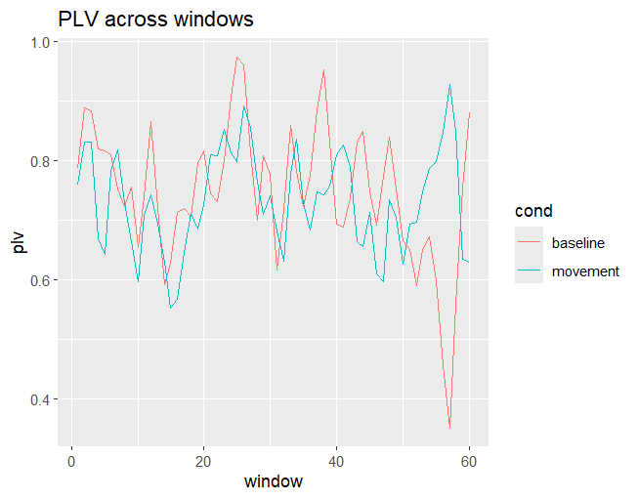

Phase coupling between C3 and C4 was quantified using the Phase Locking Value (PLV) across overlapping time windows.

The PLV plots showed that both conditions maintained moderate-to-high synchrony (PLV ≈ 0.7–0.9) throughout the recording. However, PLV during movement appeared slightly more stable, whereas baseline PLV displayed greater variability over time.

This indicates that inter-hemispheric phase synchronization remains generally strong but becomes more consistent during movement, implying that the motor cortices maintain coordinated communication when executing a motor task.

*5. Statistical Analysis*

To test whether the observed PLV differences between baseline and movement were statistically significant, both a **paired t-test** and a **non-parametric permutation test** were conducted.

* **Paired t-test:** *t = 0.9296, p = 0.3564*
* **Permutation test:** *observed difference = -0.0169, p = 0.373*

Both tests indicated **no significant difference (p > 0.05)** between baseline and movement PLV values. Although movement appeared to stabilize PLV, this change was not statistically reliable.

This suggests that while **the motor cortices remain functionally connected during both rest and movement**, the **strength of their coupling does not significantly change** across conditions. In other words, movement affects the *pattern* of synchronization (seen in coherence) rather than the *magnitude* of phase locking.

*6. Overall Interpretation*

In summary, the analyses collectively show that:

* **Alpha-band desynchronization (ERD)** occurs over the contralateral motor cortex (C3) during movement, reflecting motor activation.
* **Inter-hemispheric coherence** decreases during movement, indicating functional decoupling for efficient motor control.
* **Phase synchrony (PLV)** remains high but not significantly altered in magnitude, suggesting stable inter-regional coordination.

Together, these results align well with established neurophysiological findings: during motor activity, localized desynchronization occurs in the motor cortex while maintaining stable yet flexible communication across hemispheres.

# **Conclusion**

This project on *Time–Frequency Analysis of EEG Signals Using Wavelet Transform* provided valuable insights into the dynamic behavior of brain rhythms during rest and movement. By analyzing data from the PhysioNet EEG Motor Movement/Imagery Database (Subject S001), I was able to explore how neural oscillations in the motor cortex change with voluntary movement.

The results clearly demonstrated that **alpha-band power decreased during movement**, reflecting *event-related desynchronization (ERD)* — a hallmark of motor cortex activation. **Wavelet coherence** further revealed that inter-hemispheric coupling between the left (C3) and right (C4) motor regions weakened during movement, indicating functional decoupling as each hemisphere independently engaged in motor control. Meanwhile, **phase synchrony (PLV)** remained relatively high and stable, suggesting that both hemispheres maintained coordinated yet flexible communication throughout the task. Although statistical tests (paired *t*-test and permutation) showed no significant difference in PLV values between conditions, the patterns observed were consistent with established neurophysiological behavior during movement execution.

From a technical and learning perspective, this project was deeply enriching. It strengthened my understanding of **EEG signal processing**, **time–frequency representation**, and **functional connectivity analysis**. I learned to use **wavelet transforms** to visualize frequency changes over time, computed **band powers** for key frequency ranges, and explored **connectivity measures** such as coherence and PLV. Implementing these analyses in **R** taught me practical data handling, windowed analysis, signal filtering, and statistical validation techniques.

Beyond technical skills, the project helped me appreciate how complex and meaningful brain signals can be — how something as abstract as a waveform can reveal concrete information about movement, attention, and coordination. Overall, this study not only deepened my understanding of EEG analysis and motor neuroscience but also enhanced my confidence in working independently with real biomedical datasets, bridging the gap between theory and practical research.

# **Challenges Faced**

One of the main challenges I faced during this project was the steep learning curve involved in understanding the theoretical and computational aspects of EEG signal analysis. Before starting, many of the key concepts—such as **sampling rate**, **frequency domain vs. time domain**, **band power**, and **time–frequency analysis using wavelet transform**—were completely new to me. Grasping how brain activity could be decomposed into different frequency bands (alpha, beta, theta, delta) and how these reflect functional brain states took considerable effort and self-study.

Implementing the **Continuous Wavelet Transform (CWT)** and interpreting its outputs was another challenge. Learning how wavelet-based scalograms capture power changes over time required me to connect mathematical understanding with biological meaning. Similarly, exploring **functional connectivity** measures—like **wavelet coherence** and **Phase Locking Value (PLV)**—was complex, as they involved concepts of phase synchrony and cross-channel relationships that were initially difficult to visualize and interpret.

On the technical side, while implementing **PLV**, I faced several coding issues. Initially, the **Hilbert transform** function did not work as expected, leading to errors in phase extraction. I had to carefully debug my code, adjust the FFT-based Hilbert implementation, and verify that the instantaneous phase values were being computed correctly. This process taught me not only the importance of mathematical precision but also the need for patience and systematic problem-solving when dealing with real EEG data.

Overall, these challenges significantly enhanced my understanding of **signal processing, neural oscillations, and time–frequency methods**. Each difficulty I encountered ultimately became an opportunity to deepen my technical knowledge and build confidence in applying advanced analytical techniques to real-world neurophysiological data.